**Q1**) A section of drainage culvert 1.3 m in length makes a howling noise when the wind blows across its open ends. Determine the frequencies of the **first three harmonics** of the culvert if it is cylindrical in shape and open at both ends. use v=343 m/s as the speed of sound in air.

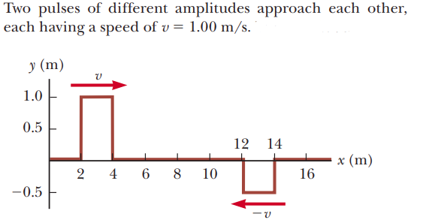**Q2**) two pulses (at time t=0s) approach eachother with a wave speed of 2 m/s

1. At what time will the two waves interfere? __________________
2. What will be the resultant amplitude in (m)? __________________

**Q3**) A standing wave is established in a 120-cm-long string fixed at both ends. The string vibrates in four segments when driven at 120 Hz.   
(a) Draw the wave, then determine the wavelength.   
(b) What is the fundamental frequency of the string?

**Q4**) A violin string has a length of 0.350 m and is tuned to concert, with f= 392 Hz. How far from the end of the string must the violinist place her finger to play concert.

**Q5)** a guitar string has a length of 70 cm vibrates in its second harmonic, knowing the speed of the wave as 420 m/s find the wavelength and frequency of this standing wave